RetailPulse Analytics Dashboard Report

Data Inspection & Cleaning Plan
Dataset Name: Sales Transactions Dataset (sales-transactions-100.xlsx)

1. Objective
To inspect the sales dataset, identify potential data quality issues, and prepare clean, reliable data for dashboard development using Power BI.

2. Dataset Overview
The dataset contains 100 rows and 7 columns: Date, Region, Product, Channel, Units, Unit Price, and Revenue. It covers sales transactions from July 2024 to June 2026.

3. Data Inspection Results
- Missing Values: No missing values identified.
- Duplicate Records: No duplicate rows identified.
- Data Types: The Date column requires validation and conversion to the Date data type if currently stored as text.
- Blank Rows: No blank records identified during the initial inspection.
- Negative Values: No negative values found in the Units, Unit Price, or Revenue columns.
- Data Consistency: Region, Product, and Channel values should be checked for consistent naming and extra spaces.
- Revenue Validation: Revenue values match the calculation of Units × Unit Price.

4. Data Cleaning Plan
- Convert the Date column to the correct Date data type.
- Verify data types across all columns.
- Check for missing values and duplicate records.
- Validate numeric values and revenue calculations.
- Check text fields for extra spaces and inconsistent naming.
- Apply necessary transformations in Power Query and validate the final dataset.

5. Expected Outcome
A clean, consistent, and validated dataset ready for Power BI dashboard development, enabling reliable analysis of sales performance by date, region, product, and sales channel.
Tools: Microsoft Excel, Power BI Desktop, and Power Query.

2. Dashboard Sketch / Wireframe
Dashboard Link:
https://claude.ai/artifact/SA44t6AD99wq3adfw2f9Kn

2. Dashboard Sketch / Wireframe
Dataset Link:

https://claude.ai/artifact/QC8dw8Nv2vsdEE7dffjPvg

3. Component Structure

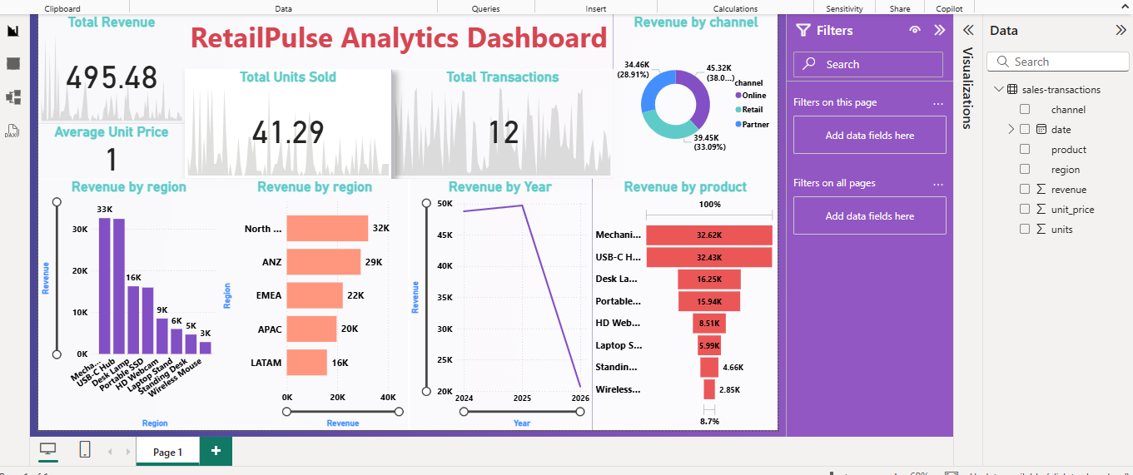

Dashboard Dataset:
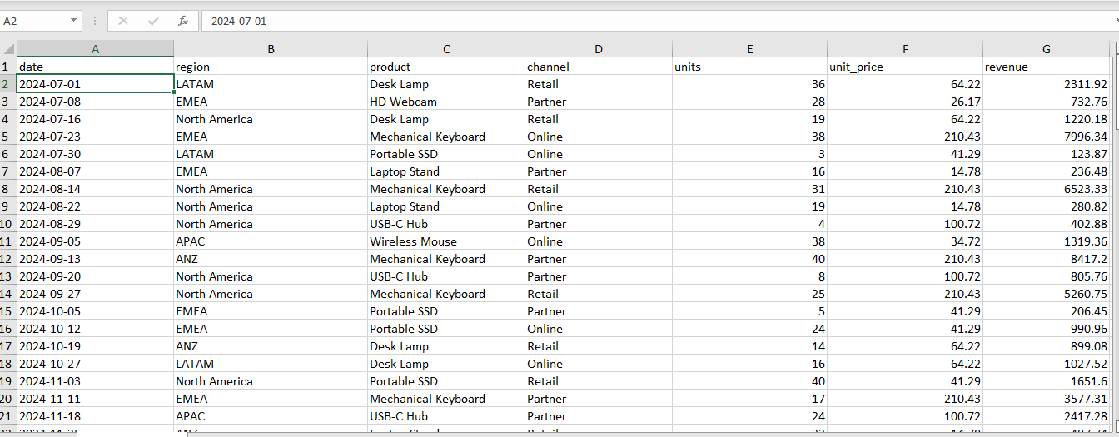
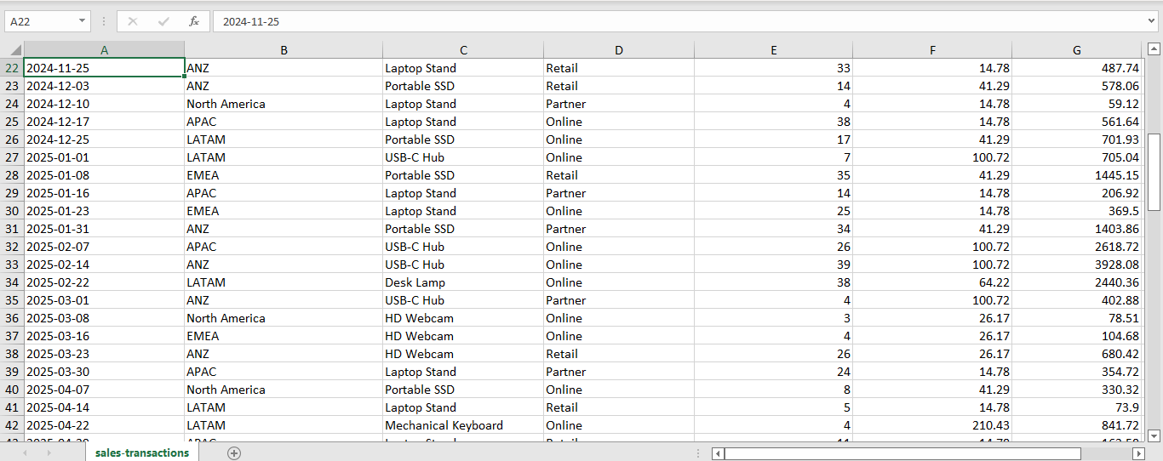

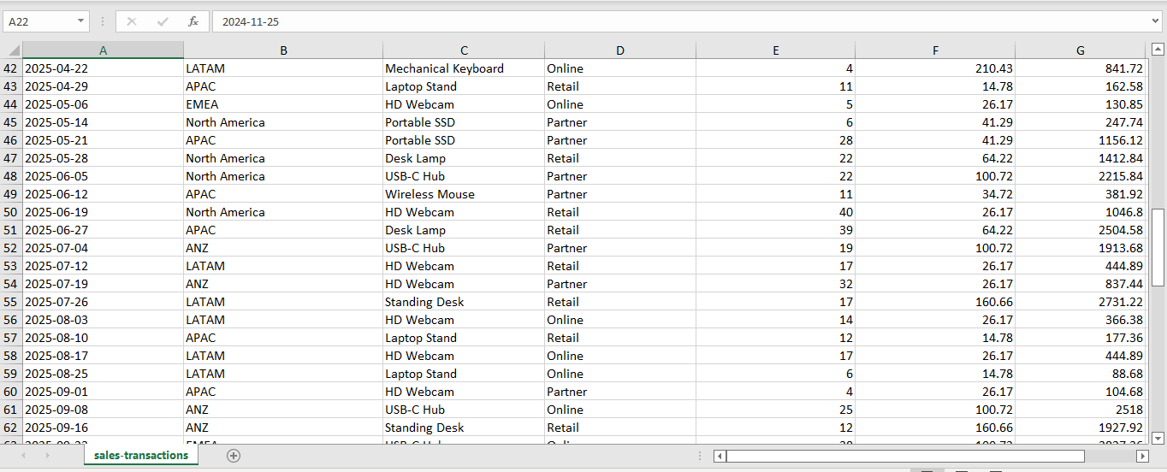

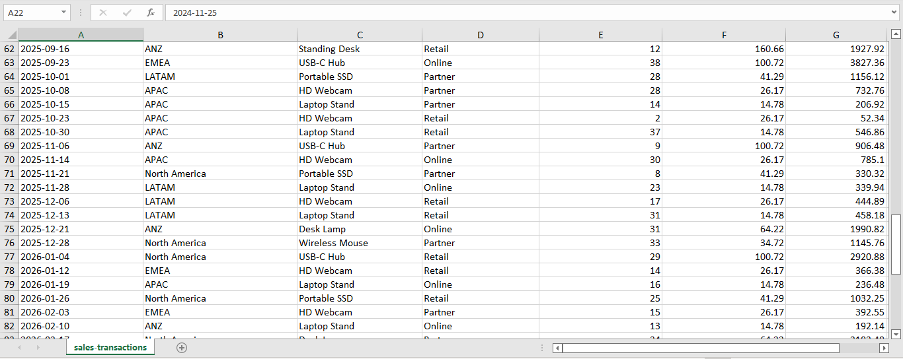

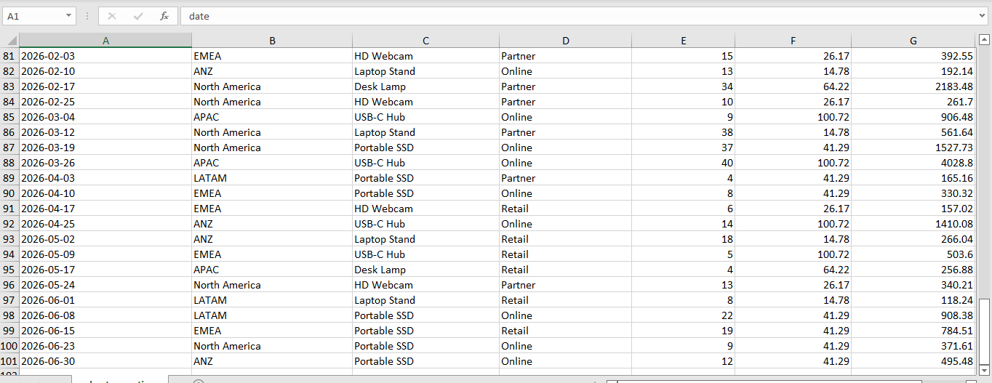

3. Dashboard Component Structure

Objective
To define the key components of the Sales Performance Dashboard and organize them to provide an interactive, user-friendly, and informative view of sales data.1. KPI Cards
KPI cards provide a quick overview of the key sales performance indicators.
- Total Sales: Displays the total revenue generated from all sales transactions.
- Total Quantity: Shows the total number of units sold.
- Average Price: Displays the average unit price across all transactions.
- Total Orders: Represents the number of orders. This metric will be defined based on the available transaction fields.

2. Slicers / Filters
Slicers allow users to interact with the dashboard and analyze sales data based on selected criteria.
- Date: Filters transactions by date or time period.
- Region: Displays sales data for a selected region.
- Product: Filters results for a specific product.
- Channel: Allows users to compare sales across different sales channels.

3. Charts and Visualizations
Charts help users identify sales patterns, compare performance, and understand trends.
- Revenue by Region – Bar Chart: Compares total revenue across different regions.
- Sales by Channel – Donut Chart: Shows the distribution of sales revenue across sales channels.
- Monthly Sales Trend – Line Chart: Illustrates changes in revenue over time and helps identify monthly sales patterns.

4. Data Table
The data table provides detailed information about individual sales transactions. It includes the following columns:
- Date
- Region
- Product
- Channel
- Units
- Unit Price
- Revenue
This table enables users to review transaction-level details and validate the information presented in the dashboard.

Expected Outcome
The component structure will provide a clear and organized dashboard layout. KPI cards will summarize key metrics, slicers will enable interactive filtering, charts will support visual analysis, and the data table will provide detailed transaction information. Together, these components will help users understand sales performance across dates, regions, products, and sales channels.
Tools: Microsoft Power BI Desktop and Power Query.

4. Environment Setup

Objective
To configure the development environment and prepare the necessary tools and dataset for building the RetailPulse Analytics Dashboard using Microsoft Power BI Desktop.

1. Tools and Technologies
- Microsoft Power BI Desktop: Used to develop the interactive sales analytics dashboard and create data visualizations.
- Microsoft Excel: Used as the source format for the sales transaction dataset.
- Power Query: Used for data inspection, data type validation, and data transformation when required.
- Sales Transactions Dataset: The Excel dataset sales-transactions-100.xlsx serves as the primary data source.

2. Environment Configuration
The Power BI Desktop environment was prepared, and the sales transactions dataset was imported into the report. The available data fields, including Date, Region, Product, Channel, Revenue, Unit Price, and Units, were verified in the Data pane.
The report workspace was organized to accommodate KPI cards, charts, and other dashboard components. The visualizations were configured to support sales analysis across regions, products, channels, and time periods.

3. Project Organization
The project is organized around the following deliverables:
- Source Data: Original Excel dataset.
- Power BI Report: Dashboard containing sales KPIs and visualizations.
- Documentation: Data Inspection and Cleaning Plan, Dashboard Wireframe, Component Structure, and Environment Setup Report.

4. Dashboard Development Status
The initial dashboard layout has been developed in Power BI Desktop. It includes KPI cards for Total Revenue, Total Units Sold, Total Transactions, and Average Unit Price, along with visualizations for revenue by region, revenue by channel, revenue by year, and revenue by product.
The report layout and visual elements have been arranged to provide a clear overview of sales performance. Further validation of calculations, visual labels, and filtering behavior will be performed before final delivery.

Expected Outcome
A properly configured Power BI development environment and an organized project structure that support reliable dashboard development, data analysis, and future enhancements.
Tools Used: Microsoft Power BI Desktop, Microsoft Excel, and Power Query.

